KENYA MEDICAL TRAINING COLLEGE

DEPARTMENT OF HEALTH PROMOTION AND COMMUNITY HEALTH

Health Communication Materials
Code: HEM 506
Hours: 60
Credit: 6

Pre-requisites
Communication skills, Health commination I, Health commination II Principles & Practice of Health Education
Module Competence
The module is designed to enable the learner develop and produce health communication materials and messages.
Module Outcomes
By the end of this module, the learner should;
  - Design health messages
  - Design and produce health communication materials
  - Develop and pre-test entertainment education concepts

Module Units
Unit Name | Hours
Unit Name | Theory | Practical
- Health message design | 10 | 10
- Designing and production of health communication materials | 00 | 30
- Entertainment education | 04 | 06

UNIT ONE: HEALTH MESSAGE DESIGN
INTRODUCTION
Health communication is a key strategy to influence (individual, inform the public about health concerns and community) to maintain important health issues on the decisions public agenda” (New South Wales Department of Health, Australia, 2006).
Definition
“The study or use of communication strategies to inform and influence individual and community decisions that enhance health” (CDC, 2001; U.S. Department of Health and Human Services, 2005).
“Health communication is a process for the development and diffusion of messages to specific audiences in order to influence their knowledge, attitudes and beliefs in favor of healthy behavioral choices” (Exchange, 2006; Smith and Hornik, 1999).
“Health communication is the use of communication techniques and technologies to (positively) influence individuals, populations, and organizations for the purpose of promoting conditions conducive to human and environmental health” (Maibach and Holtgrave, 1995, pp. 219–220; Health Communication Unit, 2006).
Key Characteristics of Health Communication
- Audience-centered
- Research-based
- Multidisciplinary
- Strategic
- Process oriented
- Cost-effective
- Creative in support of strategy
- Audience and media specific
- Relationship building
- Aimed at behavioral or social change
Steps for developing health communication materials that are evidence-based and user friendly
- Identify intended audience and define/research the key health problems or interests
- Engage the intended audiencedetermine what their needs, beliefs/values, and interests are, and their level of knowledge of the identified health topic
- Determine key concepts and messages based on knowledge of the audience
- Design a draft of the material
- Pre-test materials with intended audience
- Tweak draft according to feedback from the audience
- Publish and distribute materials
- Evaluate the audiences’ satisfaction and understanding
Types of IEC Materials
Graphics and audio-visuals — which would include brochures, posters, display boards, videotapes, slides, flip charts.
Mass media — which would include radio, television, movies, newspapers, and magazines.

Health Message Design
Make your Message Clear
Creating materials that lead to increased knowledge or a change in beliefs, attitudes, or behaviours requires messages that are clear, relevant, and appropriate for the intended audience.
Tips for deciding what to say and how to say it so that the audience will understand, remember, and act on a health message.
- Give the most important information first
- To quickly engage the audience:
- Give the most important information first
- Tell them what actions to take
- Explain why it is important to them
For example: Always wash hands with soap and warm water for 20 seconds before and after handling food. Food and water can carry germs that may make you and your family sick.
- Limit the number of messages
- Give your audience no more than three or four main ideas per document or section of your document.
- Stick to one idea at a time
- Focus on what your audience needs to know and do.
- Skip details that are only nice to know. For example if you are writing a brochure on how to prevent Lyme disease, you don’t need to tell the audience how and when Lyme disease was discovered.
- Develop one idea fully before moving to the next idea.
- People are confused when materials skip back and forth between topics.
- Avoid lengthy lists.
- Create short lists (3-7 items) with bullets, not commas. People with limited reading skills tend to forget items in longer lists. If you have a long list, break it into subheads.
- Tell audiences what they need to do.
- Clearly state the actions you want your audience to take.
- Use concrete nouns and an active voice.
- Active voice is where the subject does the action.
- E.g. Say: Follow these rules to avoid getting sick from food: For example Cook meat until it is not pink in the middle.
Wash your hands after touching raw meat.
Wash fresh fruits and vegetables before eating them.
- Tell your audience what they should do rather than what they should not do.
Use: Wear your helmet every time you ride your bicycle. Instead of: Do not ride your bicycle without wearing a helmet.
- Tell your audience what they will gain from understanding and using the material. Tell your audience how your materials will benefit them.
Answer the question, “What’s in it for me?” For example: You will learn what to do to have a healthy pregnancy and ways to prevent possible complications.
- Choose your words carefully.
Keep it short. Use words with one or two syllables when you can.
Keep most sentences, if possible, between eight to ten words and limit paragraphs to three to five sentences.
Communicate as if you were talking to a friend.
A conversational style has a more natural tone and is easy to understand.
Write as if you were talking to a friend Say: You could get sick if you are near the chemical. Not: Exposure to the chemical could cause adverse health effects. Respect and value your audience.
Don’t talk down or preach. People are less likely to act on information if they are made to feel bad about their current behavior or health situation.
Use a tone that encourages the audience. Emphasize small, practical steps. Offer concrete examples of successful action steps.
Limit use of jargon, technical, or scientific language.
Define necessary jargon or technical terms first. Then explain them in language your audience will understand. Say: high blood pressure Not: hypertension Say: birth control Not: contraception
Choose words with a single definition or connotation.
Pick the most familiar words and use them throughout your text. For example: Mad cow disease and bovine spongiform encephalitis may be the same thing, but your audience may think they are two different diseases. Avoid unnecessary abbreviations and acronyms. Provide the acronym first and then spell the word (s) out in parentheses when using a familiar abbreviation or acronym.

Pre-test any use of symbols. Use symbols sparingly for example: The following symbols may not be familiar to or have the same meaning for everyone:
Limit use of quotation marks. Choose other formats to show who is speaking when writing dialogue. For example: Jane: How hard can it be to stop smoking? Ann: Most people have a very hard time quitting. I had to try three times before I quit for good.

Text Appearance Matters
The way your text looks greatly affects readability. Choosing the appropriate font style and size is important in creating health communication materials that are easy to read.
- Use font sizes between 12 and 14 points. Anything less than 12 points can be too small to read for many audiences. Older people and people who have trouble reading or seeing may need larger print.
- For headings, use a font size at least 2 points larger than the main text size.
- Font Style; for the body of the text, use fonts with serifs. Serif fonts are usually easier to read than sans-serif fonts. This is because the serif makes the individual letters more distinctive and easier for our brains to recognize quickly. Serifs are the little “feet” on letters.
Keep the following style tips in mind:
- Do not use FANCY or script lettering.
- Use both upper and lower case letters. Do not use ALL CAPS. ALL CAPS ARE HARD TO READ.
- Use grammatically correct punctuation.
- Limit use of light text on a dark background.
- Use bold type to emphasize words or phrases.
- Limit the use of italics or underlining. They are hard to read.
- Use dark letters on a light background.
- Light text on a dark background is harder to read.
Layout and Design
Present your information and visuals in ways that make your materials easier to understand and more appealing to your audience.
- Design an effective cover
- Make the cover attractive to your intended audience.
- If the cover does not include images and colors your intended audience may not pay attention to it.
- Show the main message and audience.
- Health communication materials, such as brochures, web pages, flyers, posters, should be designed so that people are able to grasp your main idea and know who the material is speaking to just by looking at it.
- Make the cover attractive to your intended audience
- Organize your messages so they are easy to act on and recall
- Present one complete idea on one page or two facing pages.
- If people have to turn the page in the middle of your message, they may forget the first part of the message.
- Place the most important information at the beginning and restate it at the end of the document.
- It is best to state your main message first, expand on your message with straight-forward language and then repeat the main message at the end, usually with a call for change or action.
- Organize ideas in the order that your audience will use them
For example: What to do if you find a chemical spill:
  - Leave the area right away.
  - Remember where the spill is so you can avoid it.
  - Report the spill to the police or fire department.
  - Warn others to stay away from the area.
- Use headings and sub-headings to “chunk” text. Headings are a cue to upcoming message content. Use headings that express a complete idea, rather than just a word or two.
- Leave more space above headings and subheadings than below them. This gives a stronger visual link between the heading and the text that follows.
- Leave lots of white space -White space is the absence of text or visuals on a page. It keeps a page from being cramped, overwhelming, or amateurish.
- Many professional graphic designers recommend 10 to 35 percent white space per page for print materials. Leave at least 1⁄2 inch to 1 inch of white space around the margins of the page and between columns. Limit the amount of text and visuals on the page.
- Make the text easy for the eye to follow
- Break up text with bullets.
- Use right edge “ragged” or unjustified for the best readability
- Use columns.
- Columns with line lengths of 40 to 50 characters are easiest to read.
- Invite your audience into the text.
- Interaction is an effective way to increase the success of your teaching materials.
- When the audience interacts with the information provided, they are more likely to remember and act upon the information.
Translations of messages
It is best to develop your materials in the language of your intended audience. However, translating them from English (or another language) is often necessary due to time limitations and/or available resources.
Tips to help ensure that translations of your materials are both culturally and linguistically appropriate.
  - Messages that work well with an English-speaking audience may not work for audiences who speak another language. Find out about your audience’s values, health beliefs, and cultural perspectives. You can do this by conducting individual interviews, focus groups, or other kinds of audience research, including secondary research (i.e., literature reviews).
  - Design material for minority populations based on subgroups and geographic locations. All members of a minority population are not alike. Mexican Americans, for example, may respond differently than Cuban Americans to certain words, colors, and symbols. Likewise, Korean women living in New York City may view a health issue very differently from Korean women living in Los Angeles. Messages that work well with an English speaking audience may not work for audiences who speak another language
  - Get advice from community organizations in the areas you wish to reach. Local groups that work regularly with your audience can give you valuable insight about your audience. They can also recruit participants for surveys or focus group testing and help you gain the trust of your audience.
  - Carefully select your translator. Choose a qualified translator who is familiar with your intended audience. A qualified translator is typically a native speaker of the target language, has ten or more years’ experience in translation, and is preferably certified by a recognized institution. A qualified translator will produce documents that reflect the message and content of the source document. It is important to keep in mind that if the source document is not written clearly or in plain language the translated document will maintain this same attribute. When materials are used for intended audiences with more than one linguistic variation (for example, Mexican-American and Cuban-American) have multiple translators check the translation.
  - Avoid literal translations. Allow your translator to select from a wide range of expressions, phrases, and terms used by the audience. This flexibility will result in more culturally appropriate material.
  - Use the back-translation method. Once the material has been translated to the intended language, translate it back to English. (This step should be done by someone other than the original translator.) Check to see if the meaning and tone of the message have stayed the same.
  - Field test draft materials with members of your intended audience. Field testing will allow you to get feedback from your members of your intended audience and to make changes based on their comments and suggestions.

UNIT 2
DESIGNING AND PRODUCTION OF HEALTH COMMUNICATION MATERIALS

Principles of Design
The principles of design describe the ways that artists use the elements of art in a work of art.
    - Balance is the distribution of the visual weight of objects, colors, texture, and space. If the design was a scale, these elements should be balanced to make a design feel stable. In symmetrical balance, the elements used on one side of the design are similar to those on the other side; in asymmetrical balance, the sides are different but still look balanced. In radial balance, the elements are arranged around a central point and may be similar.
    - Emphasis is the part of the design that catches the viewer’s attention. Usually the artist will make one area stand out by contrasting it with other areas. The area could be different in size, color, texture, shape, etc.
    - Movement is the path the viewer’s eye takes through the work of art, often to focal areas. Such movement can be directed along lines, edges, shape, and color within the work of art.
    - Pattern is the repeating of an object or symbol all over the work of art.
    - Repetition works with pattern to make the work of art seem active. The repetition of elements of design creates unity within the work of art.
    - Proportion is the feeling of unity created when all parts (sizes, amounts, or number) relate well with each other. When drawing the human figure, proportion can refer to the size of the head compared to the rest of the body.
    - Rhythm is created when one or more elements of design are used repeatedly to create a feeling of organized movement. Rhythm creates a mood like music or dancing. To keep rhythm exciting and active, variety is essential.
    - Variety is the use of several elements of design to hold the viewer’s attention and to guide the viewer’s eye through and around the work of art.
    - Unity is the feeling of harmony between all parts of the work of art, which creates a sense of completeness.

Elements of Design
A design is a visual plan you can use to create your project. Everything you can see has a design.
When you describe something you see, you use words that tell about the lines, shapes, colors, textures, and spaces. Line, shape, color, texture, and space are the basic elements of design.
Line
Lines can be horizontal, vertical, dotted, zig-zag, curved, straight, diagonal, bold, or fine. Lines can show direction, lead the eye, outline an object, divide a space, and communicate a feeling or emotion.
Shape
Shapes are made by connecting lines. Circle, square, triangle, and freeform are words used to identify shapes. Look at the objects around you and describe their basic shapes. Are they one shape, or are they a combination of many shapes? After doing this several times, you will begin to understand what shape really is. Line creates two dimensional or flat shapes. When shapes are three dimensional, we call them forms. A circle is a shape; a ball is a form. A square is a shape; a cube is a form. A drawing is a flat shape; a sculpture is a three-dimensional form.
Color
Color is described with the words hue, value, and intensity. Hue refers to the name of the color—red or blue, for example. Value tells the lightness or darkness of a hue. Intensity refers to the brightness or dullness of a hue. You can use a color wheel and learn how colors work together in the publication, Color.
Space
Space refers to the area that a shape or form occupies. It also refers to the background against which we see the shape or form. Space can be defined as positive and negative. The positive space of a design is the filled space in the design—often it is the shapes that make up the design. Negative space is the background. The negative space in design is as important as the positive area
Texture
Texture is the surface quality of an item. It is how something feels when touched, or looks like it would feel if touched. Sandpaper is rough. Velvet is smooth. A drawing of a tree stump could show rough outer bark and a smooth inner surface. Texture adds variety and interest.
Types of Visual aids
Visual aids have many uses when giving a presentation.
Visuals can help:
- Capture attention
- Increase interest
- Clarify an idea
- reinforce a concept
- provide a reference point e.g. the spelling of an unfamiliar word, or a chart showing trends
Types of visual aids
- presentation software e.g. PowerPoint
- whiteboards
- hand outs
- overhead transparencies (rarely used)
Visual communication
Refers to communication through visual aid and is described as the conveyance of ideas and information in forms that can be read or looked upon. Visual communication solely relies on vision, and is primarily presented or expressed with two dimensional images, it includes: signs, typography, drawing, graphic design, illustration, colour and electronic resources. It also explores the idea that a visual message accompanying text has a greater power to inform, educate, or persuade a person or audience.

Methods of visual communication:
- Visual communication is the use of images, graphs, charts, and models to convey information.
- There are many different methods of visual communication that can be used to effectively communicate a message.
- Some of the most common methods include body language, logos, designs, pictures, and video graphics.
- Each method has its own advantages and disadvantages. It’s important to choose the right method for the right situation in order to create effective visual communication.

UNIT 3: ENTERTAINMENT EDUCATION
Edutainment (short for “entertainment-education”) is the use of entertainment media with educational and development objectives. Edutainment can take the form of movies, television shows, documentaries, social media campaigns, music, poems, plays and games.

Edutainment strategy is the process of entertaining people at the same time as you are teaching them something, and the products, such as any of various communication media, that do this.
Education is both a human right in itself and indispensable means of realizing other human rights. As an empowering right, education is the primary vehicle by which economically and socially marginalized adults and children can lift themselves out of poverty and obtain the means to participate fully in their communities. Education has a vital role in empowering women, street working children from exploitative and hazardous labor and sexual exploitation, promoting human rights and democracy, protecting the environment and controlling population growth
Importance of Entertainment Education:
Eliminates Boredom
Rather than staying in boring classes for many hours, entertainment eliminates your boredom by stimulating your mind and providing you with a more different and effective approach to the learning process. This approach attracts more effective and efficient responses from the learners.
Be Active
Entertainment boosts the level of activeness to students. It motivates them to work hard and dedicate themselves to the learning process. Entertainment provides the students with a fresh mind to accommodate new ideas through the learning process
Relieve Stress
How do you feel when you listen to your favorite music after a long day of lectures? It feels so good and relieving. You can watch your favorite movie or play your game whenever you feel so worked up and stressed. You can be assured that you will feel relieved and relaxed. Academic institutions have realized the need to introduce entertainment in schools to manage the stress levels amongst the students.
Promote Talents and Creativity
Research reveals that students become creative and realize their talents when they are exposed to entertainment. They become more responsive in an entertaining environment as compared to the classroom environment. Introducing entertainment programs in academic institutions will help students develop new ideas, be creative and realize their talents which will help them realize their future careers.
Better Performance
With a relaxed mind, you are assured of performing better in class or during examinations. Moreover, when students get quality entertainment, their minds relax and produce hormones that drive them to feel good and motivated to work extra hard and smart
Boosts Learning Attitude
Most students become eager to learn more and get motivated to participate in the learning process with entertainment. Few minutes of entertaining yourself can be more productive as compared to many hours of class lessons.
Improves Communication
Entertainment is one of the tools that help to improve communication between learners and their teachers. Entertaining classes makes the students view the teachers as normal human beings who can also have fun. It eliminates their fear towards the teachers and makes them develop friendships with them. The students will be free to express themselves, laugh, and engage with their teachers in other different ways. Entertainment makes the students feel more comfortable with their teachers and always consult them about anything they want to explain. This relationship between the teachers and students improves their communication with their teachers.
Bottom Line
Entertainment can easily change education from a boring experience to a more exciting process that will make you feel more motivated and develop a positive attitude towards the learning process. Moreover, entertainment will help boost the general performance of your students not only outside the classroom but also during the class lessons. This is How Technology Is Transforming How We Learn for the better.
Benefits of Entertainment Education
- EE has been demonstrated to have a wide range of public acceptance and the ability to reach several audiences.
- It promotes interpersonal and group communication and debate after exposure, thereby enhancing learning and behavior change.
- It is not restricted to one form of media, can be cost effective and has been proven successful when implemented properly.
Limitations of Entertainment Education
• The cost of EE depends upon the chosen medium of entertainment, and its ability to be competitive must be considered when choosing which medium to use. Otherwise, the audience may decide to look elsewhere.
• EE must not be looked at as the sole approach to advocacy or BCC or education.
• There are ethical considerations: it is vital that the motives of those producing the activities be unquestionable.
• Those that control the airwaves have the ability to remove a programme that they deem unacceptable

Examples of Edutainment:
Storytelling brings language learning alive and creates a participatory and immersive experience that allows Young Learners to enjoy hearing the language in a dynamic, sometimes stylistic and entertaining way. Participation using key vocabulary and phrases can create an awareness of rhythm and structure. This atmosphere of play and creative expression creates an appetite for more similar experiences. Students who have enjoyed storytelling in class often ask for more stories and also feel motivated and encouraged to create and tell, act out or illustrate their own stories in a variety of ways.
The act of storytelling appeals to different learning preferences and personalities ensuring that from the shyest to the most active of students, everyone has a chance to participate in a way that they can enjoy. This ranges from listening quietly to taking part as an actor.
Storytelling also helps students to enjoy and be aware of intonation and tone of voice, natural sounding expressions and phrases as well as interaction between native speakers.
Drama:
Drama is the expression and exploration of personal, cultural and social worlds through role and situation that engages, entertains and challenges. Students create meaning as drama makers, performers and audiences as they enjoy and analyse their own and others’ stories and points of view. Like all art forms, drama has the capacity to engage, inspire and enrich all students, excite the imagination and encourage students to reach their creative and expressive potential.
Drama enables students to imagine and participate in exploration of their worlds, individually and collaboratively. Students actively use body, gesture, movement, voice and language, taking on roles to explore and depict real and imagined worlds. They create, rehearse, perform and respond using the elements and conventions of drama and emerging and existing technologies available to them.
Students learn to think, move, speak and act with confidence. In making and staging drama they learn how to be focused, innovative and resourceful, and collaborate and take on responsibilities for drama presentations. Through role and dramatic action students explore, imagine and take risks to communicate ideas, experiences and stories.
Students develop a sense of inquiry and empathy by exploring the diversity of drama in the contemporary world and in other times, traditions, places and cultures.
Radio and Television:
Radio is sound communication by radio waves, usually through the transmission of music, news, and other types of programs from single broadcast stations to multitudes of individual listeners equipped with radio receivers.

Benefits of Radio:
- Inclusion - A School Radio station run by the students and for the students will help build an inclusive atmosphere in the school. Radio is all about communication and running a radio show takes commitment and teamwork in order for it to be a success. Our systems are easy enough to use that all students, regardless of age or ability can get involved.
- Building Confidence - Most people find talking to a 'mic' in a closed room far less intimidating than appearing on camera or on stage. This allows students to express their views and build their confidence whether it is discussing important issues or sharing ideas, radio gives your students a confident voice within your school.
- Develop Speaking & Listening Skills - Radio is about speaking and listening. Whether you are presenting or just listening to a show, these vital skills are not only fundamental in radio but are essential for 'real world' skills
- Improving Literacy - Seems strange to be talking about writing skills in radio but the first time a student looks at the 'mic' and then asks what they should say, they realise they need to write scripts and prepare between links. Extend this preparation for talk shows, radio drama or telephone interviews and it is clear that writing plays a big role in radio and extends to meeting the National Curriculum in many ways.
- National Curriculum - School Radio helps schools and academies to supplement learning and meet the National Curriculum in ways that you may not even realise. It’s also a great way to keep staff, student and parents/guardians alike updated with school life. Have a look at our summary page and see a few examples.
- Giving Students A Voice and Empowerment- School Radio offers a platform for your students to discuss the issues that matter to them in a non-confrontational format. Whether it is discussing important issues or sharing the music they love, radio gives your students a voice within your school.
- Teamwork - Planning and presenting radio shows requires a great deal of teamwork. Many schools run their School Radio station like a ‘real’ station assigning roles and responsibilities for presenters, engineers and station management. See our free resources pages to download packs to work on projects as a team.
Television is an inescapable part of modern culture. We depend on TV for entertainment, news, education, culture, weather, sports—and even music, since the advent of music videos.
Benefits of television:
- Because of its ability to create powerful touchstones, TV enables young people to share cultural experiences with others.
- TV can act as a catalyst to get kids reading—following up on TV programs by getting books on the same subjects or reading authors whose work was adapted for the programs.
- Television can teach kids important values and life lessons.
- Educational programming can develop young children’s socialization and learning skills.
- News, current events and historical programming can help make young people more aware of other cultures and people.
- Documentaries can help develop critical thinking about society and the world.
- TV can help introduce youth to classic Hollywood films and foreign movies that they might not otherwise see.
- Cultural programming can open up the world of music and art for young people.
There are three general approaches to the use of radio and televising broadcasting in education:
1). direct class teaching, where broadcast programming substitutes for teachers on a temporary basis,
2). school broadcasting, where broadcast programming provides complementary teaching and learning resources not otherwise available,
3). General education programming over community, national and international stations which provide general and informal educational opportunities. Students are exposed to a variety of teachers on television but have one home teacher at the school for all disciplines in each grade
There are also those programs aimed at the general public with objectives other than the entertainment of viewers and profitability. Such programs include documentaries on environmental issues, history, culture and arts. Public health features and civic education programs are included in this category.
Examples of Education programmes in Kenya:
Kenya Broadcasting Corporation:
- Adult and Continuing Education, an adult literacy program on the English service of KBC radio,aired on Fridays at 4p.m.
- UNESCO Documentary on KBC television on Tuesday and Thursday
- Chakula Bora on Sundays at 6.30.p.m
- NTV
C21 ,an environmental awareness feature.
- National Geographic ,feature documentaries on environmental and anthropological issues.
British Broadcasting Corporation (BBC)

- Kimasomaso ,a Swahili radio program on youth sexuality
Educational programmes have been used to instigate behavior change that can result in healthier lifestyles and environmental sustainability. For instance, the use of radio is achieving considerable success in changing and enhancing knowledge and attitudes on topics including HIV/Aids, family planning, mother and child health, environmental issues, social and administrative issues and gender equality. Radio is also shown to have had a positive impact on uptake of health services, enrollment in literacy classes, construction of environmentally friendly wood stoves, tree-planting, agricultural yields and awareness of strategies for poverty reduction though income generation and community associations.
Poem:
A piece of writing in which the expression of feelings and ideas is given intensity by particular attention to diction (sometimes involving rhyme), rhythm, and imagery.
Poetry can be a powerful teaching tool, helping students improve their literacy. It can also allow writers to express their emotions and allow readers to connect to those emotions. Poetry is also connected to aesthetics, or the exploration of what is beautiful in the world.
The poetry of a particular culture is important when it comes to understanding that culture's history and values. In some cases, poetry can help build community among people, both through mutual self-expression and through people sharing poetry that they love with others.
Benefits of Poetry:
Improves language skills:
The process of writing poetry can build vocabulary. Individuals will learn how to incorporate new words when writing and understand their meanings. Poetry writing will expose individuals to literary device such as alliteration, metaphors and personification. Their writing skills will improve and writing essays, reports and emails in the future will become easier. Poetry can also be performed live, also known as a poetry slam.
Sparks creative thinking:
Creativity is important when it comes to writing poetry. When someone writes a poem, it forces their brain to come up with creative ways to form sentences to create the structure of a poem. Rhyming is the most common literary device used in poetry. Writers need to be creative in making sure the poem has a flow and the meaning is successfully conveyed.
Creative self-awareness:
Poetry writing helps people discover who they are. It helps individuals stay in tune with their thoughts and feelings. Through writing, a person can find out more about their personality, likes and dislikes; passions and interests. Poetry is also a good way to express opinions on certain issues. If read by others, poetry can help people connect with one another and start conversations.
As a therapeutic activity:
The activity of poetry writing is not only healthy for the mind but for the soul as well. Poetry is an outlet to express frustration, anger and negative thoughts in a safe way. Writing is a therapeutic process that can turn a bad day into a good one. When a poem is written, it results in a sense of accomplishment and pride which in turn increases self-confidence.
Expand world views:
Those who are passionate about poetry have a chance to widen their world views. They can draw inspiration from what is going on in the world today and turn them into important poems. This will make the writer understand a certain issue better by seeing it from different perspectives. A person who has wide world views can grow to become more empathetic and tolerant.

Songs/Music:
A song is a short poem or other set of words set to music or meant to be sung or a musical composition intended to be performed by the human voice.
Music is powerful. Music has a definite impact on us in most if not all aspects of our lives. Music can change the mood of a person, act as a carrier for suggestions, and even influence the mind.
Benefits of songs/Music:
Music is used in a professional setting as a means of therapy. Music Therapy is an established healthcare profession that uses music to address physical, emotional, cognitive, and social needs of individuals of all ages. Music therapy improves the quality of life for persons who are well and meets the needs of children and adults with disabilities or illnesses. Music therapy interventions can be designed to:
- promote wellness
- manage stress
- alleviate pain
- express feelings
- enhance memory
- improve communication
- Promote physical rehabilitation.

Public Engagement in Music Activities
- Music events that enable collaboration between artists, fans, and development and health actors can stimulate the development of critical thinking, collaboration, and empowerment that Freire defined as a ‘problem-posing’ approach to education . By involving artists and audiences in dialogue and mutual learning, music-based interventions can enable local voices to be heard, contribute to collective empowerment, and help communities define their goals and priorities.

- Through songs, performances, and actions, music artists activated their fans to advocate for public health. One of the songs produced during the early stages of the pandemic provides an example of how music may be a useful tool in youth engagement in COVID-19 prevention.

Music is a universal language that can be understood by anyone
- Many people believe that music is a universal language. This means that, regardless of what country someone is from, they will be able to understand and enjoy a song without knowing the lyrics. Since music doesn’t rely on words, it has the ability to connect two different cultures in a way that no other form of communication can.

Music is Useful to Mark Special Occasions and Gatherings
- Since songs can hold so much importance to people, they are often used as a way to commemorate moments in time. Whether it’s at a wedding, funeral or any other special occasion, music is always present and can help make the moment even more memorable.
Music can represent what is unique in a culture.
- Music, in a way, is a reflection of what people think is unique about their culture. For example, if someone from America listens to music from India, they can learn some things about Indian culture and tradition. This is because many of the songs that come out of the country contain references and influences from their religion and/or history. This lets people get a sense of the type of life Indians live, which then gives them a better understanding about their culture.
Music helps people relax and get over anxiety/stress.
- Everyone gets stressed or anxious from time to time, even if it’s not about school or work pressures. Some individuals use music as a way to calm themselves down when they’re feeling this way. A lot of people listen to their favorite songs when they’re in bed or taking a shower, as it can help them relax.
Music is a form of entertainment and art.
- Aside from its function of bringing people together, music is also used for entertainment and art purposes by some cultures. For example, a lot of modern music is composed in a very creative way and has some degree of artistic value.
Plays/Theatre Education:
Theatre in education goes beyond entertainment because it creates a creative environment that changes the student’s attitudes, behaviour, and knowledge. The importance of theatre in education is evident in how it creates a holistic learning environment that develops students emotionally, intellectually, socially, and physically.
Globally, schools recognise drama and art as some of the best ways to promote emotional intelligence and impart soft skills to youngsters.
Benefits of role plays:
Enhances Learning
The use of role plays and art in education attracts the attention of students in the subject matter. Most students are receptive and enjoy learning from performing or watching educational theatre because it makes it easy to remember important facts.

Enlightens Students of Prevalent Issues in Society
Theatre is the most realistic form of education that promotes engagement in students. The stories presented through theatre are often hard-hitting topics based on real-life events and prevalent issues affecting society. Thus, drama benefits students by encouraging them to reflect on the personal issues raised and shed light on how different social topics affect them and the world around them rather than ignoring them.
When students are knowledgeable about issues of interest to society or contemporary life problems, it is easy to make sense of them and handle them. Hence, enacting real situations prepares students to face challenges in real life.
Develops a Sense of Creativity and Imagination
Another benefit of incorporating drama and theatre in education is that it inspires creativity and imagination by encouraging students to view opportunities and problems from an artistic angle. When faced with challenges, it is easy for drama students to manage their way out of them because they are used to embracing creativity in similar scenarios.
Provides A Platform to Continue the Conversation
Students may be curious to find out why a character made certain decisions or what caused them to behave in a particular way. Theatre encourages students to continue conversations on the topics and give opinions even after the end of the production.
Builds Self-Regulation and Social Skills
Another importance of role plays in education is that it teaches students to deal with vulnerable emotions and everyday challenges in a supportive and safe environment. Performing or witnessing different strategies playing out encourages students to explore diverse perspectives and build social awareness. Children develop empathy for others and understand their emotions better as they enact different roles. Role plays makes it easy to appreciate the reason for the existence of challenging situations, conflicts, and challenging characters.
Theatre is also an effective way to teach students self-regulation by demonstrating conflict resolution and anger management skills. They learn tools for managing emotions and explore options for seeking health, which improves their overall mental wellbeing.
Instills Positive Values
Theatre activities impart numerous positive values to students. Role plays requires students to work together to get everything right. As a result, they learn important life skills, such as compassion, cooperation, and teamwork. The creative art form also teaches problem-solving because they learn how to behave and react in certain situations.
Role play allows students to make better decisions by stimulating critical thinking skills, reasoning, and memory. Many students use theatrical performance to break down stereotypes and promote better morals.

Promotes Physical Development
Theatre is physically demanding, just like sports. Enacting role play includes lots of movement and dancing, which improves the physical development of students. They have a chance to develop control and strength over their mind and body.
Helps Students Create Lasting Friendships
A role play is a fun activity that students enjoy doing together, whether they’re experts or beginners. Students who participate in drama have a common interest that makes it easy to develop lasting friendships. Such friendships can have a positive impact on their confidence, creativity, motivation, and achievements in life.

ENTERTAINMENT EDUCATION:
Edutainment (short for “entertainment-education”) is the use of entertainment media with educational and development objectives. Edutainment can take the form of movies, television shows, documentaries, social media campaigns, music, poems, plays and games.
of entertaining people at the same time as you are teaching them something, and the products, such as any of various communication media, that do this.
Education is both a human right in itself and indispensable means of realizing other human rights. As an empowering right, education is the primary vehicle by which economically and socially marginalized adults and children can lift themselves out of poverty and obtain the means to participate fully in their communities. Education has a vital role in empowering women, street working children from exploitative and hazardous labor and sexual exploitation, promoting human rights and democracy, protecting the environment and controlling population growth
Importance of Entertainment E
E PRACTICAL INSTRUCTIONS
  - How to Create a Flyer in Microsoft Word Using Templates
Word offers a variety of ready-made templates to help you customize a flyer. Here's how to get these templates:
- In Word, go to the File tab and select New.
- Under the search bar, select Flyers.
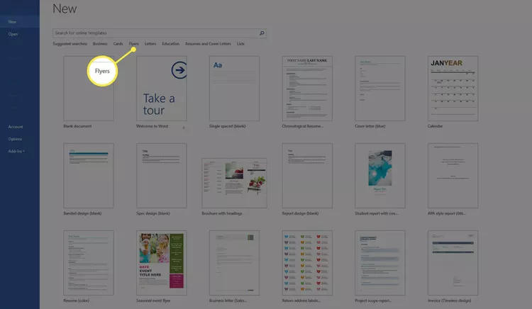
- Browse through the free flyer templates Word displays until you find a design you like.
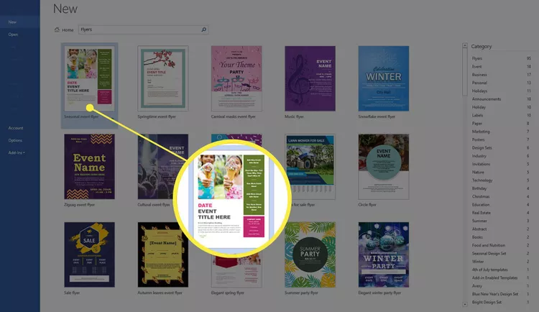

- Choose Create.
If you can't find a template you like, download one from Microsoft.
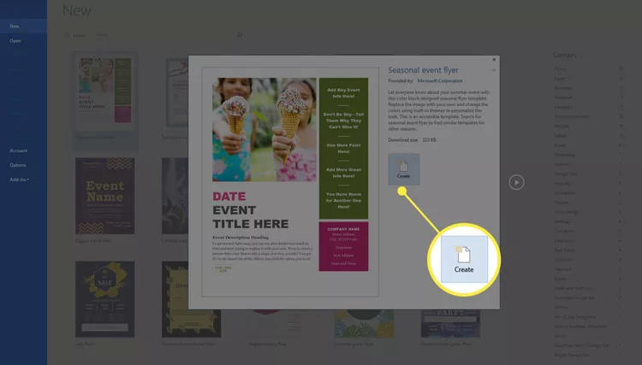

5.To change the text, select it and type the new information.
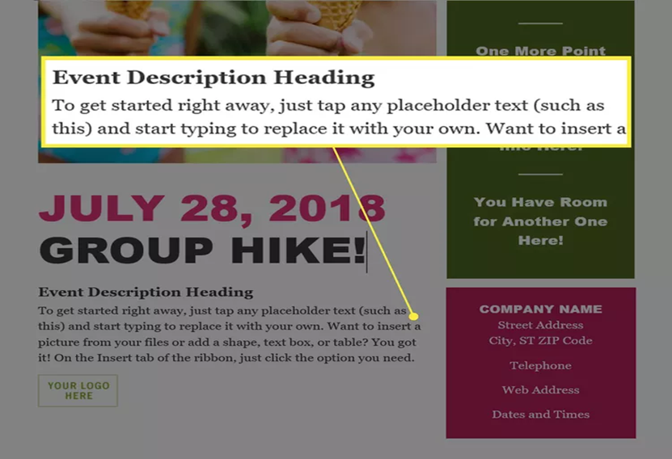

- To change the image, right-click the existing one, then select Change Picture. In the Insert Pictures dialog box, select From a file. Browse to an image on your computer then select Insert.﻿

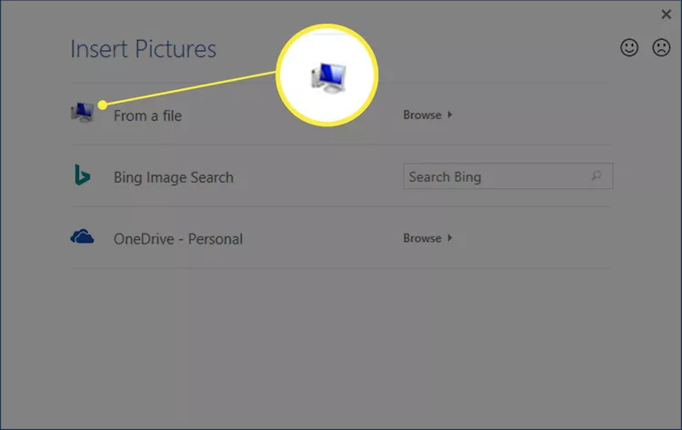
- To change the color or another design feature of a content box, right-click the box and choose the appropriate menu items to alter the element. To delete an unwanted element, select it and press Delete on the keyboard
- Save the flyer, then print it or send it in an email message.
- To change the color or another design feature of a content box, right-click the box and choose the appropriate menu items to alter the element. To delete an unwanted element, select it and press Delete on the keyboard.
- Save the flyer, then print it or send it in an email message.
Saving the changes to a document doesn't change the template. When you open the template again to start a new flyer, it appears the same as when you first opened it.
2. How to create a Podcast on a smart phone:
- Go to play store
- Download a podcast app on your phone. e.g Podbean app,Anchor app
- Install the podcast app.
- Then tap the Podbean app to get started
- Press the record button
- Speak using the microphone about the title and the message (tap on the microphone icon)
- Press the stop button
- Click preview audio
- Click start – you are able to listen to the audio recorded
- Save
- Add episode
- Example: Benefits of Covid 19 vaccination
- A display appears ready to Publish
- Click ok and the record is published.
Note:
The person should choose the title or topic of Interest.
Edit the post description on a paper before recording.

3. How to develop a poster through publisher
Starting Publisher
- Double click the Publisher Icon on your desktop.

- You will be taken to the ‘getting started’ area of Publisher
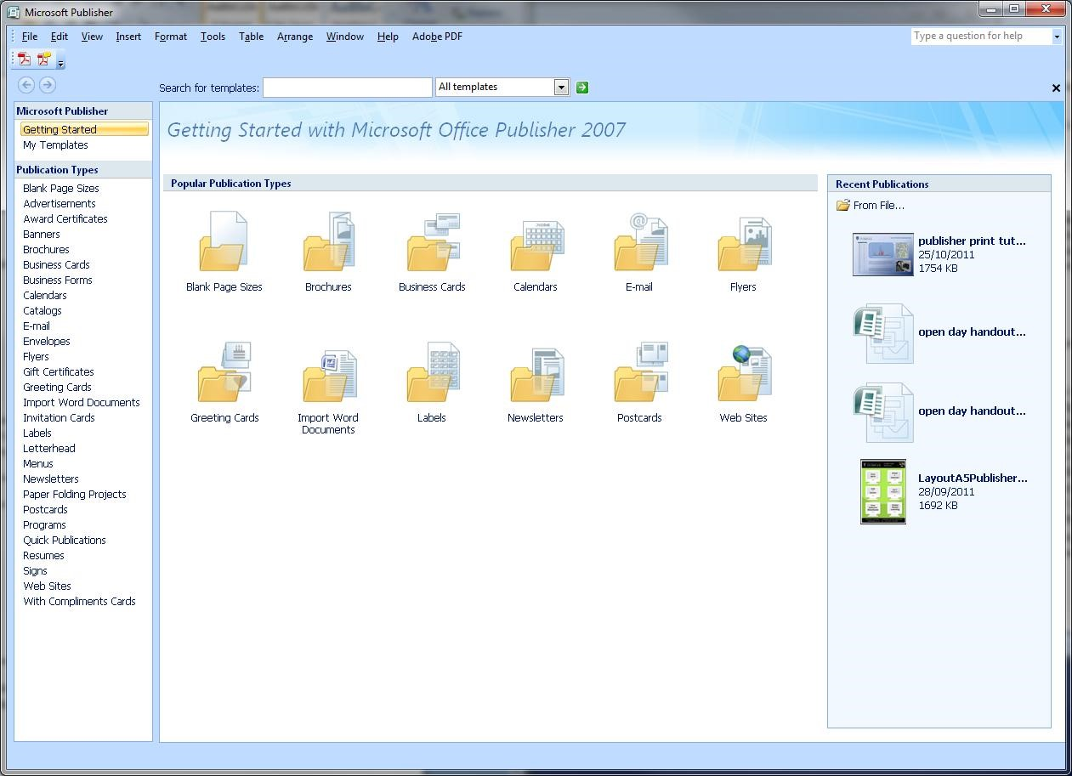

Create a Poster Template
Before you start creating posters, you need to create a poster template. Conferences and research seminars will usually give a specification of thesize and orientation of the poster to be submitted. The most common size of poster is A0.
- Click Blank Page Sizes

- You will see a screen similar to the one below.
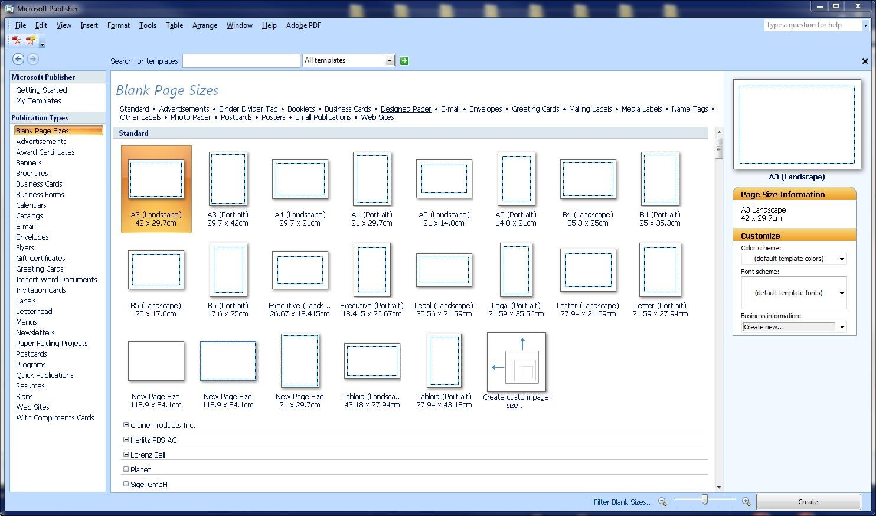
- Click Create custom page size
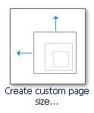

- A dialog box will appear :
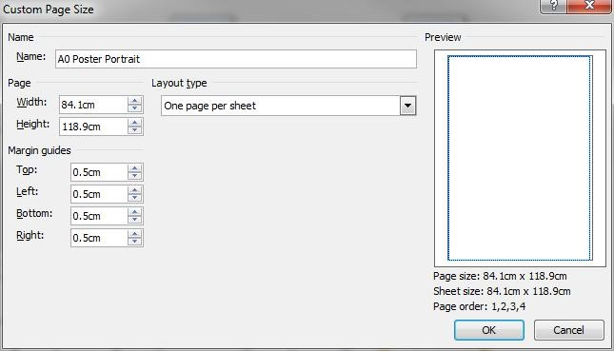
- Enter ”A0 Poster Portrait” in the name box.
- Enter “84.1cm” for the width and “118.9cm” for the height,
- Enter ”0.5cm” in each of the boxes under margin guides (left,right,top,bottom)
This will set the page size to that of an A0 landscape poster with a 5mm margin. If you wish your poster to be portrait, switch the numbers for the height and width.
- Press OK.
The dialog box will disappear and a new icon will appear under Blank page sizes
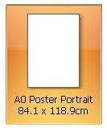
Clicking this new icon will open a Publisher workspace
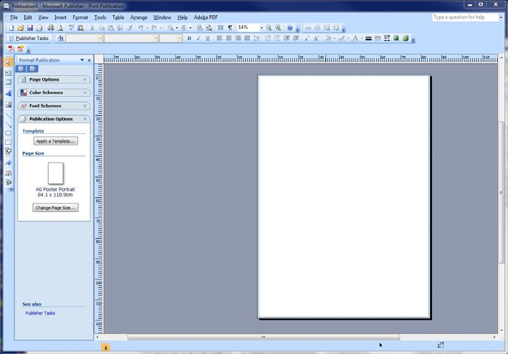

Edit the Page size of a template
If you have made a mistake, or you wish to change the page size or change the margins:
- Click the Change Page Size button in the left hand menu,
- Hover over the A0 poster template, click the blue arrow,

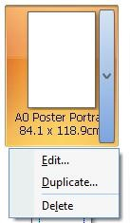

- Click Edit from the menu,
- The custom page size dialog box should appear, make your changes then click OK.
Aligning your images and text
The two most popular ways to align your images and text are using layout guides and ruler guides.

Layout Guides
Layout guides give you the option to divide the poster up into sections to help you place your various elements.
To turn the Layout Guides on:
- On the Task menu, click Arrange
- Click Layout Guides from the drop down menu.
- Replicate the settings as shown in the image below:
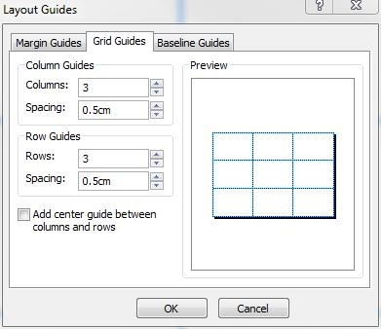
In this example the page is divided into nine sections in a 3x3 grid. Each section has a 5mm margin or padding, and 3 pictures have been added to highlight the usage of such a layout. The Layout guides are represented by dotted blue lines.
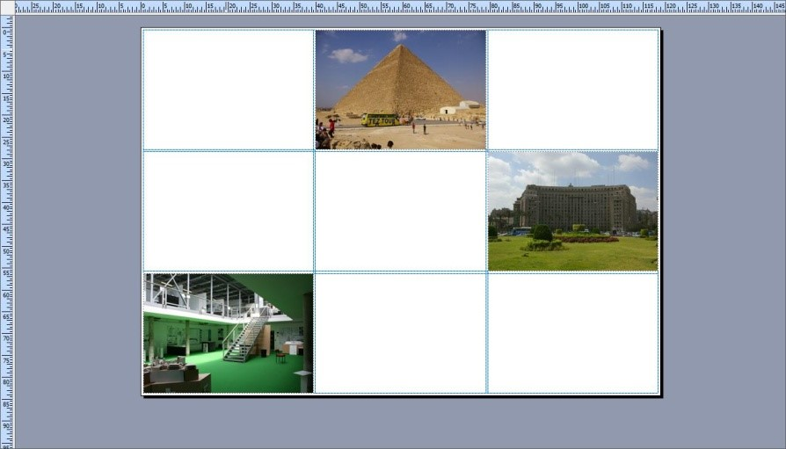

Ruler Guides
Ruler guides are another way on aligning our elements either horizontally or vertically.
In the example below, two ruler guides have been used to align a picture and a text box. The guides are represented by two thin green lines.
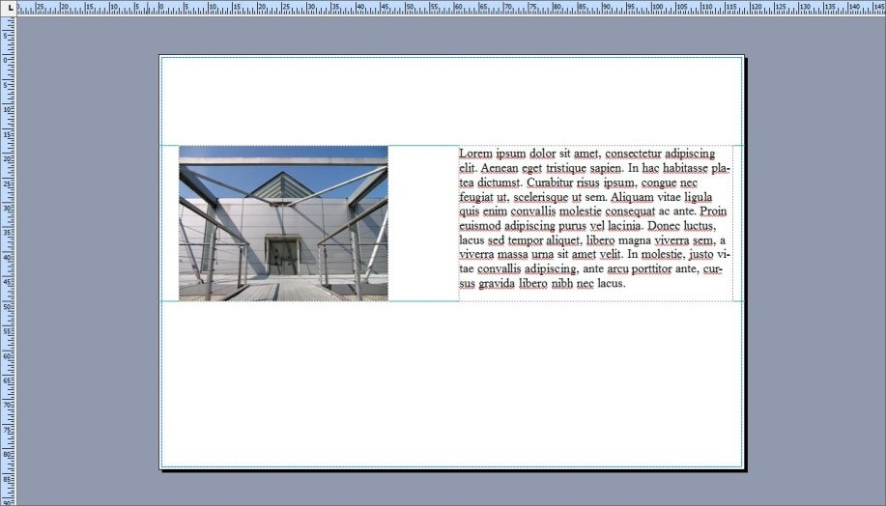
To add a ruler guide :
- Click Arrange
- Select Ruler Guides and select from the menu, Add Horizontal Ruler Guide or Add Vertical Ruler Guide.

Apply a Background
The 4 most popular backgrounds for posters are:



Gradient Pattern

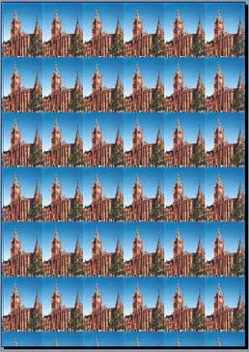

Solid Single Colour Picture
To apply a background
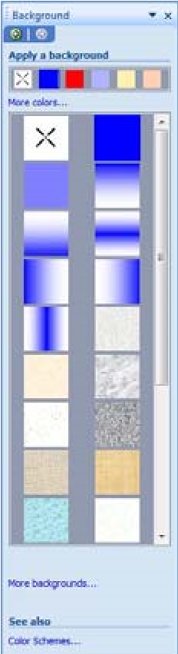
- On the Task menu, click Format and then Background.

A column of options will appear on the left, this is called the Background Task Pane.

You can select a background from any of the options presented, or you can choose to create one from associated dialog boxes.

Apply as solid colour
- Click on the More Colors link in the Background Task pane to bring up the colour gamut dialog box.
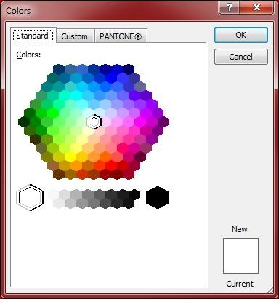
- Select a base colour from the graphic in this dialog box and press ok. All the colours in the Format Backgrounds Task Pane on the left will change to reflect the new colour.
- Choose the square with the one solid colour from this panel to apply the fill to the background.

Apply a gradient
You can choose from one of the many gradients available from the Format Background task pane or you can make a custom gradient.
To select a custom gradient:
• Click the More backgrounds link from the task pane, this will bring up the Fill Effects box • Click the Gradient tab
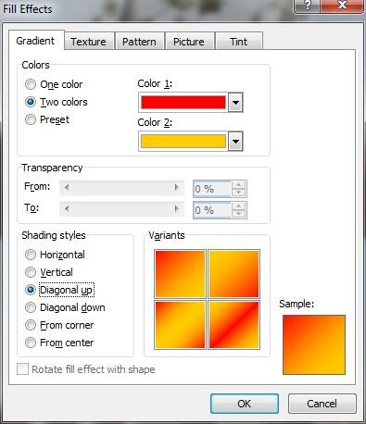
There are many different gradients which can be achieved using different combinations of options available in this dialog. The sample box in the bottom right hand corner of the dialog box will give you an indication to what your gradient will look like.

Apply a Texture
As with the gradients options, you can choose a texture from the task pane. If there aren’t any to suit you, there is the option to select your own from file.
To select a Custom Texture :
- Click the link for More backgrounds....
- In the Fill Effects dialog box, click the Texture tab
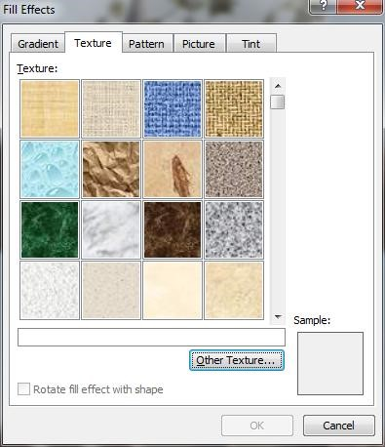
You can select a texture from the many listed or you can use the other texture button to select a picture file to base your own texture on. Again the sample box will give you a quick preview of what the background will look like

Apply a picture as a background
Publisher will tile a picture set as a background picture depending on the physical size of the picture, i.e. the smaller the picture, the greater the number of tiles. You set the background picture this way by the following steps : • Click the link named More backgrounds....., and click the Picture tab
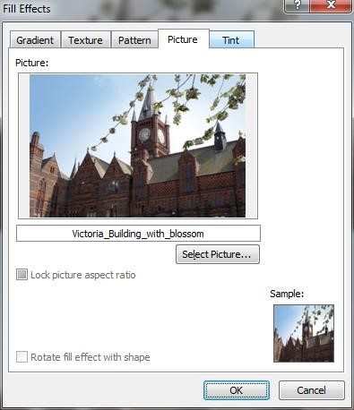
- Next, click the Select Picture button. A browser dialog box will pop up, navigate to where your picture is stored, click on it, and click OK
- Click OK on the fill effects dialog box.
The picture you used tiled on the background
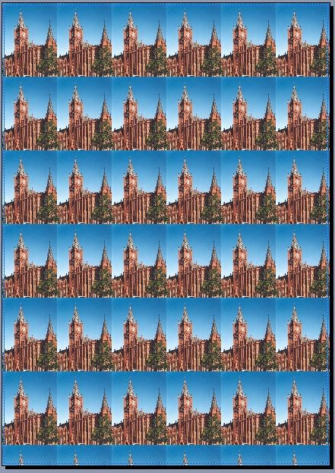

If this is not a suitable background for the poster and a single picture is preferred, follow the steps outlined below.
- Click Insert , Picture ,From file...,
- This will bring up a browser window, navigate to and select the file you wish to use click OK The picture you have chosen will be placed in the centre of the work area as shown :
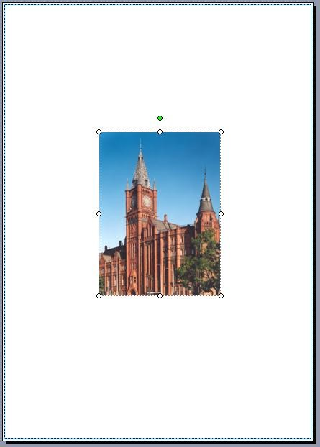

- Use the mini circles around the edge of the picture to resize the picture to the extent of the margins as illustrated in the next graphic below/
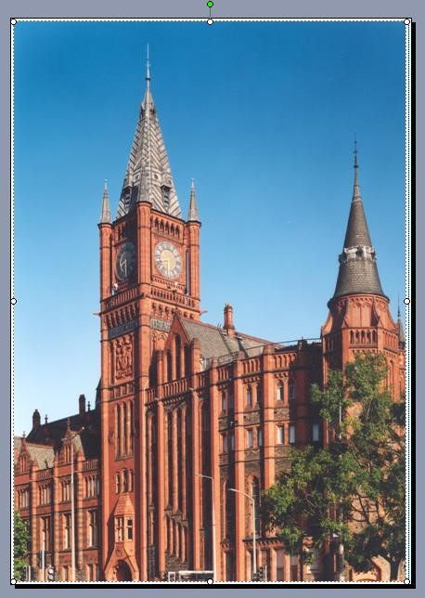
- Next, right click on the picture, in the Context menu, select Order then left click Send to back The image will now lay behind everything else in the work area.

Add Text to your Poster.
The most effective way to read text on a poster is to break it down into small manageable chunks. This is best achieved using text boxes.

To insert a text box
- Click insert
- From the drop down menu click Text Box.
- The cursor will change to a cross, left click to place the cursor on the Publisher workspace.

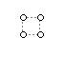
- Click inside the box to enter your text.
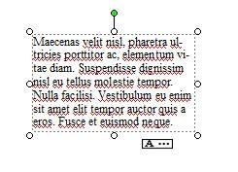
- If you find that you do not have enough room to display all of your text, you will see the following symbol underneath the text box: , In this case you will need to resize the text box.

- Left click and drag the small circles on the text box corners to resize the textbox.

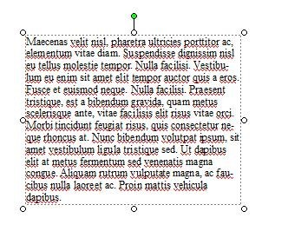

Rotate
You can also rotate the text box by, clicking on the green control at the top of the textbox and dragging in a circular motion.
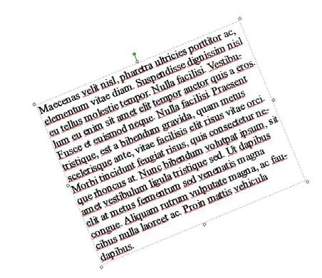

Text Input
To insert text into a text box:
- Click inside it and a flashing cursor will appear. The text box is ready to accept typing.
- You can also copy and paste text from Word documents or Internet Explorer into text boxes. • The way to change the font, size, and colour of text is very similar to that of Microsoft Word.
- All the controls are in the formatting toolbar under the menu bar.

Adding Pictures to your Poster
There are 2 ways to add pictures to a Publisher document.
You can either drag an image from the desktop or
You can use the Insert Picture function.

Insert a Picture
- Click insert
- In the drop down menu hover over Picture and from the menu select From File
- This will open a browser window to ‘pictures’. You can however, navigate to other folders from here.

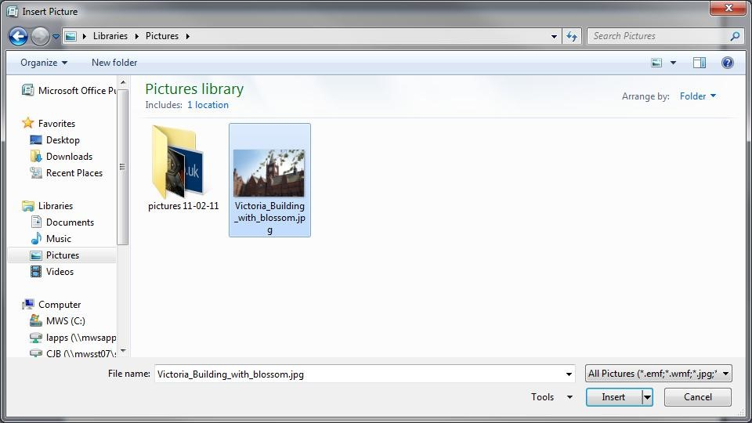

- Select the picture file that you want to use and click the Insert button.

Resize
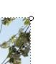
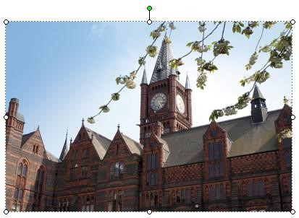
Resize the picture using the small circular picture size controls on each corner and edge of the box surrounding the picture.

Note : Try to avoid resizing small pictures and thumbnails to a large size as this may distort the image.

Movement and Rotation
When you move your mouse over the middle of the picture, the cursor changes to look like  this means that you can move your picture over the workspace by left click and dragging the picture.
You can rotate the picture by clicking and holding the green control at the top of the picture and dragging around it.
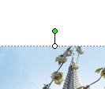

Rotated To the Right :
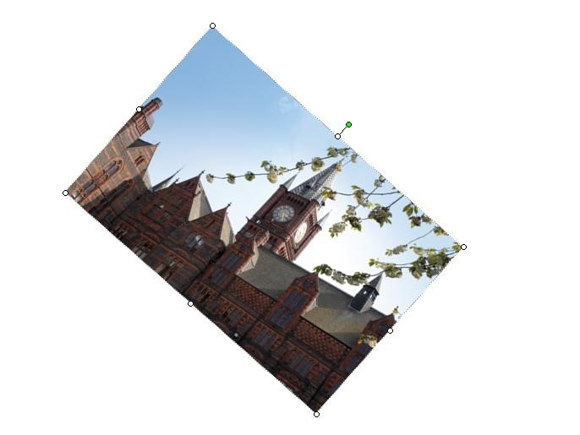

Add Graphs and Tables From Excel.

Insert a Table
You can copy and paste charts and tables from Excel into Publisher, or you can ‘link’ the files so that any updates to the Excel spreadsheet will be reflected in the Publisher document.

Link an Excel file
- To link a table in Publisher to an Excel file:
- Select and copy the cells in Excel.
- Open your Publisher document
- Click Edit and click Paste Special from the drop down list.
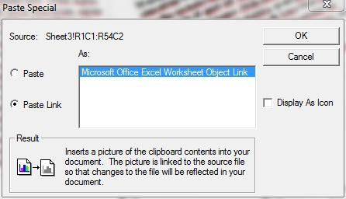

- Click the radio button marked ‘Paste Link’
- Make sure the “Microsoft office Excel worksheet object link” is highlighted • Click OK
The selected spreadsheet will appear in the Publisher document.
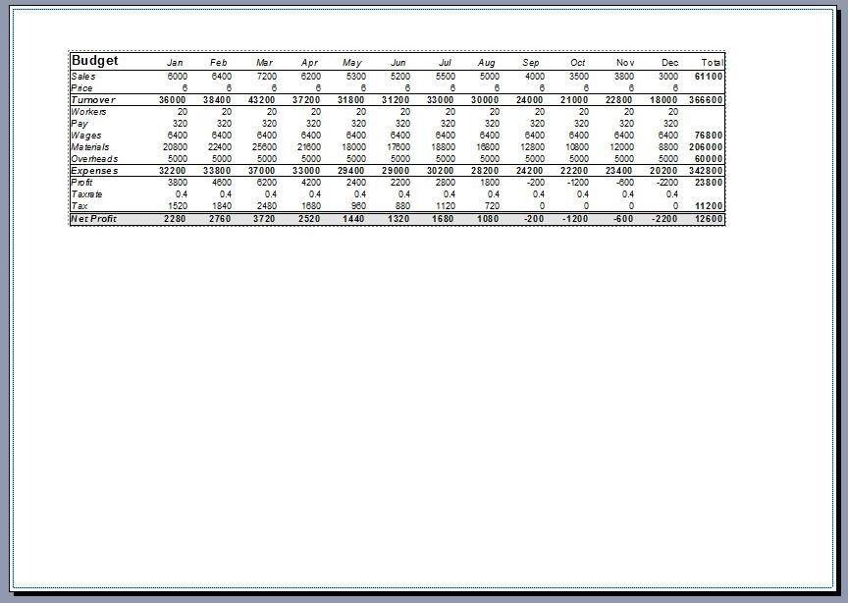

Insert a Chart
You can copy and paste charts from Excel into Publisher.
Note : to make it easier to discern which charts are being inserted, give each chart its own sheet in Excel. To do this, follow the steps below.
- Open Excel
- Make the worksheet with the chart in it active.
- Right click in the box containing the chart
- Select Move chart from the menu
- Click New sheet and insert a suitable name for the sheet • Click OK

You should have a new sheet in the Excel work book that you have appropriately named.

NOTE : You may see a warning in Excel disabling data connections in yellow at the top of the workbook. Please click the button and click ‘enable content’
To Insert the chart into Publisher:
- Click Insert
- Click ‘Object’ from the drop down menu

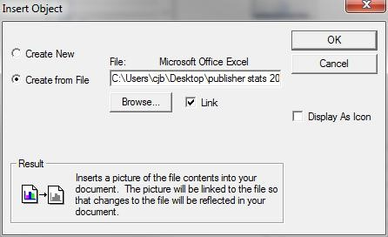

- Click the radio button called ‘Create from file’
- Put a check in the box called ‘Link’
- Click the Browse button
- Navigate and select your Excel file
- Click Open
- Click OK
Your chart will appear in the middle of the workspace.
Just resize and move as you would a picture or a text box.

- How to create a health text message:
Send a text message
You can send a text message to one or more people to start a new conversation.
- Open the Messages app .
- Tap  at the top of the screen.
- Enter the phone number, contact name, or Apple ID of each recipient.
Or tap , then choose contacts from the list.
Note: If your iPhone is set up with Dual SIM, you can also tap your number to switch to your other outgoing line.
- Tap the text field above the keyboard, then type your message, or tap  to dictate text.
- Tap  to send.
If a message can’t be sent, an alert  appears. Tap the alert to try sending the message again.
You can add photos, audio,videos, or emoji, or access other special features such as animated effects, stickers, songs, and more with iMessage apps.
Examples of health Messages:
MOH-CHANJO
Hi Dorine, you are scheduled to take your 2nd dose of covid vaccine on 14/06/2023 at Port reitz sub county hospital. MoH.
“Zero malaria starts with me”
“Kick Polio out of Kenya”
“Mukitupenda Tuchanjeni” – child vaccination slogan

References/Further Readings
Baran, J. & Dennis K. (2007). Mass communication theory. Wadsworth Cencage (pub). United States.
Centre for Disease Control. (2014). Simply Put, A guide for creating easy-to-understand materials, Atlanta, Georgia.
Maibosh, E. & Louisella R. (1995). Designing Health messages. Sage Publishers. India.
Nelson, D. E. Parvanta, S. A. & Harner, R. (2011). Designing Health messages. Jones and Bartlett Learning, LLC. (Pub).
O’Sullivan, G. A. Yonkler, J.A. Morgan, W. & Merritt, A.P. (2003). A Field Guide to Designing a Health Communication Strategy, Johns Hopkins (Pub).
Schiavo, R. (2007). Health communication from theory to practice. Jossey, B. (pub), United States.

nates Boredom
Rather than staying in boring classes for many hours, entertainment eliminates your boredom by stimulating your mind and providing you with a more different and effective approach to the learning process. This approach attracts more effective and efficient responses from the learners.
Be Active
Entertainment boosts the level of activeness to students. It motivates them to work hard and dedicate themselves to the learning process. Entertainment provides the students with a fresh mind to accommodate new ideas through the learning process
Relieve Stress
How do you

